Chapter 5, Problem 29

Determine the voltage gain v_{o}/v_{i} of the op amp circuit in Fig. 5.67.

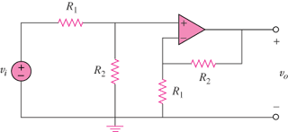

Figure 5.67
For Prob. 5.29.

